### [**It's a Small Paper World**](https://papercraftetc.blogspot.com/2014/06/its-small-paper-world.html)

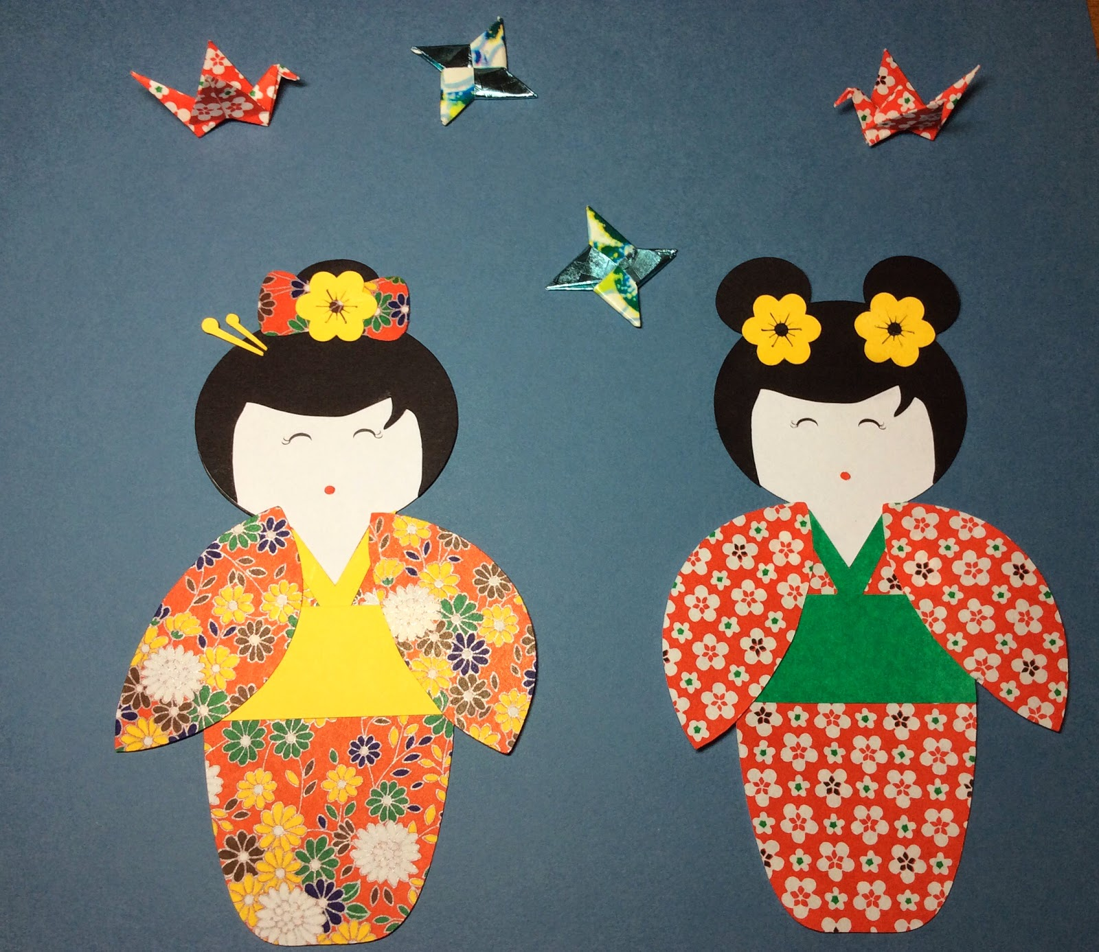

When I was twelve years old, I went to Disney World in Orlando, Florida. My favorite pavilion was "It's a Small World". I loved the music and all of the animated dolls. I want to recreate those memories by making paper dolls. My first attempt is Japan with a Geisha girl. I also added a small origami ninja star and a small crane.

Instructions for the Ninja Star.  
<http://www.origami-instructions.com/origami-ninja-star.html>Instructions for the Crane.  
<http://www.origami-instructions.com/origami-crane.html>